KITH & KIN INTERNATIONAL COLLEGE

*7/11 Kaoli Olusanya Street, Owode Ibeshe, Ikorodu, Lagos State.*

**THIRD TERM EXAMINATION 2024/2025 ACADEMIC SESSION**



|  |  |  |  |  |  |  |  |
| --- | --- | --- | --- | --- | --- | --- | --- |
| **NAME** |  | |  | | |  | |
| **SUBJECT** | **BASIC SCIENCE** | **CLASS** | | **JSS 1** | **DURATION** | | **2 HOURS** |

SECTION A

OBJECTIVE [50 MARKS]

INSTRUCTION: ANSWER ALL QUESTIONS IN THIS SECTION

1. The diagram shows the male reproductive and urinary systems .

Which structure produces the fluid part of semen ?

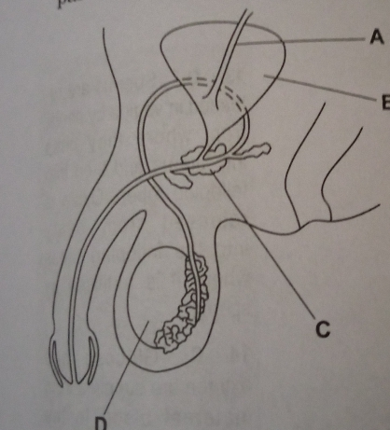



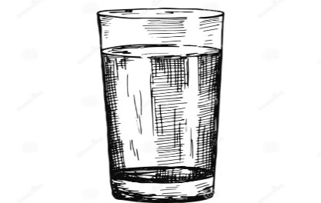

What is the compound name for the diagram above?  
A. Fe2SO4

B. H2O

C. H2SO4

D.Na2SO4

1. The diagram shows a foetus in the uterus .

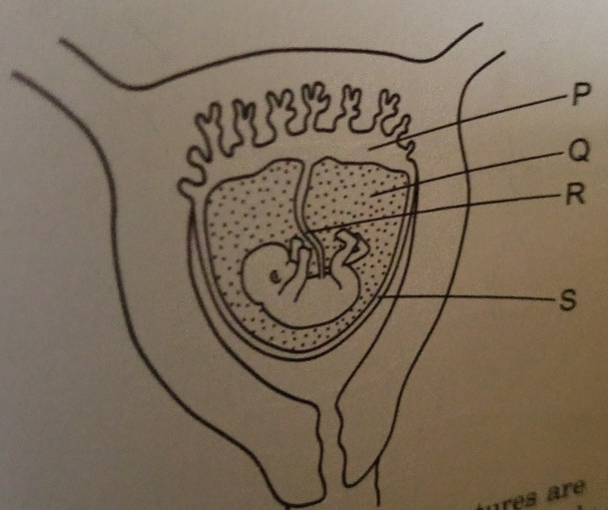

Which of the labelled structures are essential for feeding the foetus and which for supporting it and protecting it from mechanical shocks ?

|  |  |  |
| --- | --- | --- |
|  | Feeding | Supporting and protecting |
| A | P and Q | R and S |
| B | P and R | Q and S |
| C | Q and S | P and R |
| D | R and S | P and Q |

1. The diagram shows the female reproductive system.

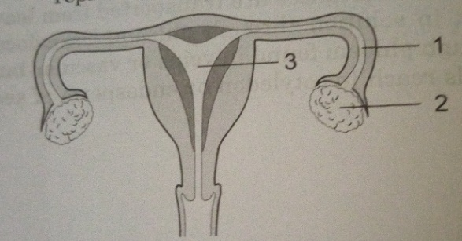

In which parts are the eggs and the zygote formed ?

|  |  |  |
| --- | --- | --- |
|  | Egg | Zygote |
| A | 1 | 2 |
| B | 1 | 3 |
| C | 2 | 1 |
| D | 2 | 3 |

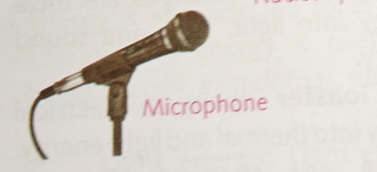

The type of energy transformation in the diagram above is

1. Electrical to mechanical energy
2. Electrical to sound energy
3. Electrical to light energy
4. Electrical to wind energy
5. What is force ? A force is a thing that
6. Changes the shape of a body
7. Makes a body at rest move
8. Changes the speed of a moving body
9. All of the above
10. One of the following is not a type of force
11. Reversible
12. Magnetic
13. Gravitation
14. Electrical

1. When you push down on a spring mattress , the spring mattress reduces in size . As soon as you let go the force you applied , the spring mattress bounces back to its normal size . This shows that :
2. Forces occur in pairs
3. Air is pushing the mattress
4. A force is not involved
5. Contact force is acting

1. Which of the following is NOT an example of a force?
2. Tension
3. Pull
4. Motion
5. Push
6. The driver of a fast moving lorry suddenly applies brake and the lorry stops , what type of force is involved ?
7. Magnetic force
8. Electrical force
9. Frictional force
10. Gravitational force

1. Gravitational force is a force of ______
2. Opposition
3. Separation
4. Friction
5. Attraction
6. The earth has a large gravitational pull on object because the earth
7. Is large in size
8. Acts as magnet
9. Revolves
10. Rotates
11. The earth gravitational pull on an object is represented by that objects
12. Volume
13. Size
14. Weight
15. Height above the ground
16. When a metal ball of 20kg and a wooden ball of 10kg are dropped from the same height
17. Both balls will reach the ground at the same time
18. The metal ball will reach the ground before the wooden ball
19. The wooden ball will fall side ways
20. The metal ball will fall side ways
21. In outer space , there is no earth gravitational pull and a person’s experience _____ there
22. The mass of the object
23. The mass of the earth
24. The distance between the center of the object and the earth
25. Weightlessness
26. _____ is a large body of rock or gas that orbits the sun.
27. Moon
28. Planet
29. Pluto
30. Jupiter
31. The planet , the sun and other smaller objects make up the ____
32. Planet
33. Neptune
34. Solar system
35. Uranus
36. The inner planets are :
37. Jupiter , Mercury ,Venus >Mars
38. Mercury , Neptune , Mars , Earth
39. Mercury , Venus , Earth , Mars
40. Venus , Uranus , Mars , Venus

1. Which of the planet as a lot of oxygen in its atmosphere?
2. Jupiter
3. Sun
4. Mars
5. Earth
6. Which of the planets have orbits smaller than the asteroids belt and hence refers to as the ___
7. earth ‘s moon planet
8. gas inner planets
9. outer planet
10. middle planet

21. Gravitational force is a force of ?

1. Attraction
2. Friction
3. ?Repulsion
4. Separation

22. Space travel is done in which of the following?

1. Space jacket
2. Helicopter
3. Passenger planes
4. Spaceships

23. Which of these is a satellite?

1. Atmosphere
2. Sea
3. Moon
4. Sun

24. Satellites can be used for

1. fireworks
2. motorcars
3. communication
4. lighting

25. __________________ is a body that orbits a planet?

1. Sun
2. Dwarf
3. Satellite
4. Earth

26. Which of the following is not true of energy?

1. Energy is the ability to do work
2. Energy cannot be changed from one form to another
3. Energy cannot be created
4. Energy cannot be destroyed

27. Which of the following is an artificial satellite?

1. Mercury
2. Jupiter
3. Reconnaissance satellite
4. Moon

28. Which of the following is not a type of artificial satellite?

1. Communication satellite
2. Weather satellite
3. Observation satellite
4. Moon

29. Which of the following is called satellite of the earth?

1. Asteroid
2. Moon
3. Comet
4. Sun

30. The function of vitamin C in the body is to

1. assist in blood clotting
2. build the body
3. help in healing wound
4. help in respiration

31. Which of the following energies is contained in foods ?

1. Chemical
2. Heat
3. Light
4. Mechanical

32 . When drugs are taken without the doctor’s advice is called , it is called drug

1. abuse
2. addiction
3. medication
4. meddling

33. The scientist who studies weather is called

1. weather forecaster
2. scientist
3. meteorologist
4. astronomist

34. The S.I. unit of force is

1. joules
2. newton
3. metre
4. kilowatt

35. Which of these is NOT a source of energy?

1. Coal
2. Smoke
3. Petroleum
4. Natural gas

36. Forms of energy include the following except

1. nuclear
2. sound
3. wind
4. chemical

37. Calculate the potential energy (P.E) of a 50kg man standing on a wall 15m tall from ground; g = 10m/s2 [P.E = mgh]

1. 7.50Joules
2. 75.00 Joules
3. 750.00 Joules
4. 7500.00 Joule

38. Which of these is not true of a force?

1. It causes motion of a body
2. It tends to cause motion of a body
3. It keeps a body moving
4. It stops a body from moving

39. Causes of drug abuse include the following, except

1. curiosity
2. education
3. frustration
4. peer group

40. The following are characteristics of living things except

1. Excretion
2. Expansion
3. Growth
4. Reproduction

41. Which of these is a source of renewable energy ?

1. Coal
2. Petrol
3. Crude oil
4. Water

42. The unit of mass is called

1. centimetre
2. litre
3. newton
4. kilogramme

43. The air we breathe in is found in the

1. stratosphere
2. atmosphere
3. ionosphere
4. troposphere

44. Bread and yam are examples of the class of food called

1. carbohydrates
2. fats
3. proteins
4. starch

45. The correct formula of potential energy of a body of weight mg at height h is

1. mg
2. mgh
3. mg/h
4. mg/2h

46. _______ satellites are satellites designed to carry micro-organism generally used for scientific experimentation

1. Bio-satellites
2. Communication satellites
3. Navigation satellites
4. Space station satellites

47. Calculate the K.E of a moving car having the mass of 100 kg at a speed of 2m/s2. [K.E= 1/2MV2]

1. 200 J
2. 20 J
3. 2 J
4. 0.2 J

48. The number of satellite in jupiter is

1. 12
2. 5
3. 2
4. 0

49. Which of the following is a symptoms of pregnancy?

A. Cough

B. Yellow eyeball

C. Long leg

D. Nausea

50 . Fusion of both male and female reproductive cells in the fallopian tube is called __________________

A . menstruation

B. ovulation

C. fertilization

D.pregnancy

**SECTION B- THEORY**

***Answer only* four *questions from this part [40 marks]***

1. SECTION B

[40 marks]

Answer **FOUR**  questions in these section. Question number **ONE** is compulsory. Answer question number one with any other three .

All questions carry equal marks. Credit will be given for clarity of expression and orderly presentation of material.

PART I : ALTERNATIVE TO PRACTICAL (COMPULSORY)



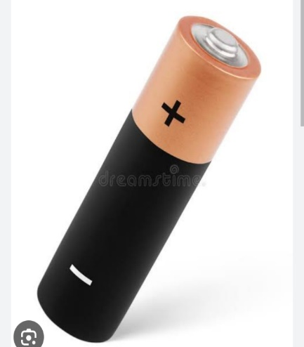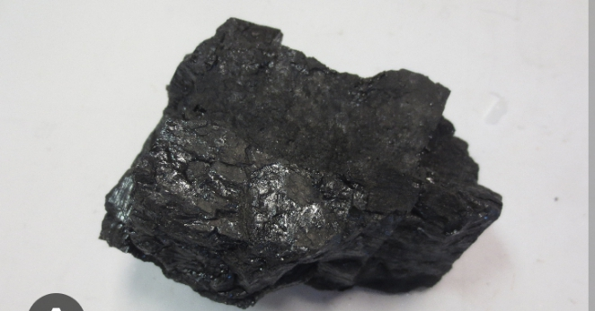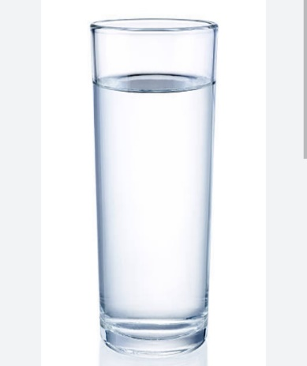 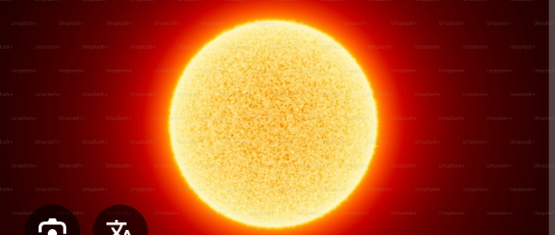

1. Identify the types of energy shown in the diagram above [4marks]

(b)Define friction [2marks]

(c)State 4 uses of friction [4marks]

PART II: Answer three questions from this part

1. Define the following
2. Eclipse of the sun
3. Eclipse of the moon
4. Gravitation
5. Weightlessness
6. Centrifugal force

[10marks]

1. (a) Explain what causes
2. Day and night
3. Seasons of the year [5marks]

(b) Mention five uses of planets [5marks]

1. (a) Define the following
2. Ovulation
3. Fertilization
4. Menstruation
5. Menstrual hygiene [4marks]
6. State three menstrual hygiene practices [3marks]
7. State three symptoms of pregnancy [3marks]
8. (a) A ball 20kg is lifted up a height 10meters .Calculate the gravitational force . Note g=9.8m/s [4marks]

(b) State two examples of contact force [2marks]

(c) State two examples of non-contact force [2marks]

(d) State two differences between contact force and non- contact force [2marks]